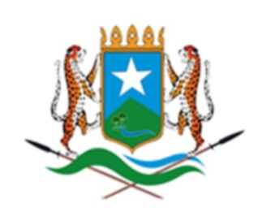

دولة إقليم هيرشابيل

**الصومالية**

**Dowlad Goboleedka Hirshabelle**

**ee Soomaaliya**

**HIRSHABELLE STATE OF SOMALIA**

**CIVIL SERVICE COMMISSION**

**VACANCY ANNOUNCEMENT**



|  |  |
| --- | --- |
| **Job title:** | **Protocol Officer** |
| **Ministry /employing authority:** | **State Presidency** |
| **Department:** | **Protocol and Public Relation** |
| **Reporting to:** | **Protocol and Public relation director** |
| **Grade:** | **6** |
| **Salary:** | **$ 502** |
| **Hours** | **36 hours per week** |
| **Location:** | **Jowhar- Hirshabelle** |

1. **Purpose of the position**

The Protocol officers will assist protocol and Public relation director in organizing and planning official visits within their jurisdiction in the state president, such as visits of foreign delegations, the diplomats and other dignitaries. Offer hospitality and ceremonial events as well as by providing support services related to protocol matters.

1. **Duties and responsibilities**

• Give escort officers information on the specific protocol requirements concerning the guests.

• Assist the protocol and Public relation director to organize ceremonies for treaty signings, conducting swearing-in of cabinet ministers and state arrival ceremonies and maintaining of presidential palace.

• Support Plans to execute detailed programs to leaders visiting the President and accompany them during their official travel towards the national and other FMS, including their visit with the President at the Presidential Palace.

• Support the Preparation of weekly and monthly reports as per the directives of the director.

• Carry out any other duties as assigned by the management

1. **Qualifications and experience**

• Diploma in political science, public relation business administration and/or Public Administration.

• 3 years related work experience in related field.

1. **Competencies**

• Strategic information and records management skills

• Computer literacy

• Good ethical values of Honesty, integrity and confidentiality

• Professional development skills

• Flexibility and ability work on multiple tasks/projects concurrently

• Ability to meet critical deadlines while maintaining accuracy

• Abilities to motivate and mentor state presidency staff.

• Excellent communication skills both written and oral for Somali and English languages

**How to apply**

**Please download Application** **Form: Application form** 

Interested candidates who meet the criteria are encouraged to fill the application form and send **to recruitment.hirshabelle@gmail.com** by not later than **21-March 2024**.

**NOTE**

• Please quote the position you are applying in the subject of the e-mail.

• Application form should be sent as attachment in word format.

• Female and people with disabilities are highly encouraged to apply.

• Canvassing will lead to automatic disqualification.

• Only shortlisted candidates will be contacted.

• If you are shortlisted for an interview, you will be required to come with your original academic and professional certificates during the interview day. For more information, please visit the following website. www.somalijobs.co